CDC Comparison

*Using High as a predictor for >15 per 100k*

Using the indicators (low, medium, and high risk of COVID-19 surges), we find that there is relatively low correlation between the predicted probability of exceeding hospital capacity and the actual probability.

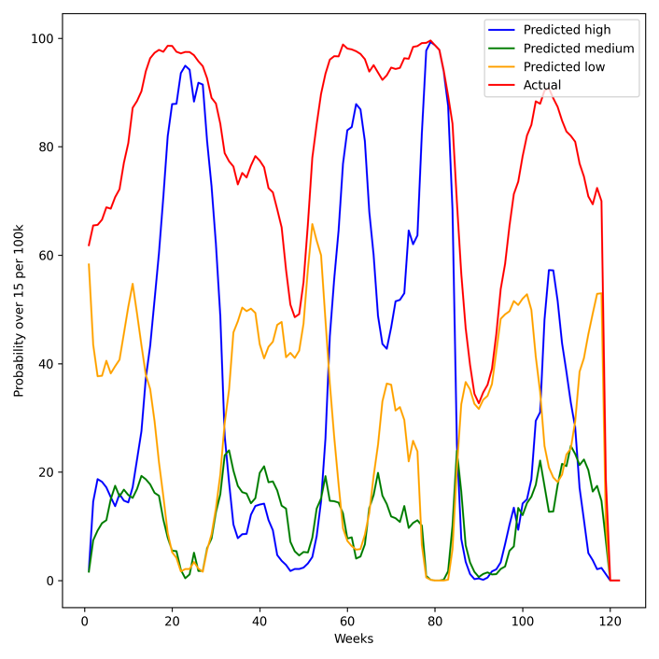

|  |  |  |  |  |  |
| --- | --- | --- | --- | --- | --- |
|  | Accuracy | Sensitivity | Specificity | PPV | NPV |
| Simple predictor |  |  |  |  |  |
| Optimized decision tree |  |  |  |  |  |
|  |  |  |  |  |  |
|  |  |  |  |  |  |

If we use the raw data, rather than the converted metrics, we can optimize a decision tree ourselves: